RESULTS

Throughout this section, CP+number will indicate the number-th Covid Passport intervention.

Table 1 provides estimates and 95% confidence intervals on trend (t1) before the intervention, the difference in level (NPI) after the intervention and the change in trend (t2) after the intervention for all NBSR models. Except from hospital admissions in Wales and Northern Ireland, the results suggest that Covid Passport had a positive effect in the reduction of both cases and hospital admissions for all the countries of the UK apart from England, as all the respective relevant t2 coefficients are negative. The confidence intervals are quite wide but the results from NBSR are generally reinforced by the ARIMA models.

 |  |  | Wales CP1 | Wales CP2 | Northern Ireland CP1 | Scotland CP1 | England CP1
Cases | Negative Binomial Segmented Regression | Estimate t1 | 0.01 | 0.01 | 0.01 | 0.01 | 0.02
Cases | Negative Binomial Segmented Regression | 95% CI t1 | (-0.01,0.03) | (-0.01,0.04) | (0,0.02) | (-0.02,0.04) | (0.01,0.03)
Cases | Negative Binomial Segmented Regression | Estimate t2 | -0.03 | -0.01 | -0.01 | -0.01 | 0
Cases | Negative Binomial Segmented Regression | 95% CI t2 | (-0.06 , -0.01) | (-0.05 , 0.03) | (-0.03 , 0.01) | (-0.05 , 0.04) | (-0.01 , 0.01)
Cases | Negative Binomial Segmented Regression | Estimate NPI | 0.22 | -0.19 | -0.13 | -0.04 | 0.56
Cases | Negative Binomial Segmented Regression | 95% CI NPI | (-0.02 , 0.46) | (-0.50 , 0.12) | (-0.31 , 0.04) | (-0.40 , 0.34) | (0.43 , 0.70)
Cases | ARIMA | Estimate t1 | -0.33 | 1.15 | 1.05 | 0.33 | 1.31
Cases | ARIMA | 95% CI t1 | (-3.03,2.38) | (-0.65,3.06) | (0.55,1.55) | (-2.70,3.37) | (0.39,2.23)
Cases | ARIMA | Estimate t2 | -1.73 | -1.62 | -0.16 | -2.30 | 4.07
Cases | ARIMA | 95% CI t2 | (-4.61 , 1.15) | (-4.35 , 1.11) | (-3.05 , 2.73) | (-5.46 , 0.87) | (1.48 , 6.67)
Cases | ARIMA | Estimate NPI | 39.30 | -10.60 | -12.40 | 32.33 | 78.00
Cases | ARIMA | 95% CI NPI | (7.85 , 70.79) | (-31.31 , 10.13) | (-30.25 , 5.43) | (-0.37 , 65.03) | ( 44.93 , 111.04)
Admissions | Negative Binomial Segmented Regression | Estimate t1 | 0 | -0.01 | -0.02 | 0.01 | 0
Admissions | Negative Binomial Segmented Regression | 95% CI t1 | (-0.21,0.22) | (-0.08,0.05) | (-0.06,0.02) | (-0.15,0.17) | (-0.03,0.04)
Admissions | Negative Binomial Segmented Regression | Estimate t2 | 0.02 | 0.02 | 0.02 | -0.03 | 0.01
Admissions | Negative Binomial Segmented Regression | 95% CI t2 | (-0.26 , 0.27) | (-0.12 , 0.11) | (-0.10 , 0.13) | (-0.25 , 0.20) | (-0.04 , 0.06)
Admissions | Negative Binomial Segmented Regression | Estimate NPI | 0.2 | -0.11 | 0.16 | -0.04 | 0.64
Admissions | Negative Binomial Segmented Regression | 95% CI NPI | (-2.44 , 3.10) | (-1.67 , 1.47) | (-1.16 , 1.43) | (-2.12 , 2.14) | (-0.31 , 1.63)
Admissions | ARIMA | Estimate t1 | 0 | -0.02 | -0.03 | -0.67 | 0
Admissions | ARIMA | 95% CI t1 | (-0.05,0.04) | (-0.03,0) | (-0.04,0) | (-4.07,2.74) | (-0.01,0.03)
Admissions | ARIMA | Estimate t2 | 0.02 | 0.02 | 0.01 | -2.16 | 0.05
Admissions | ARIMA | 95% CI t2 | (-0.04 , 0.07) | (-0.01 , 0.04) | (-0.03 , 0.06) | (-6.98 , 2.65) | ( 0.02 , 0.09)
Admissions | ARIMA | Estimate NPI | 0.32 | -0.11 | 0.35 | 34.33 | 1.14
Admissions | ARIMA | 95% CI NPI | (-0.25 , 0.89) | (-0.39 , 0.17) | (-0.19 , 0.88) | (-11.20 , 79.87) | (0.53 , 1.75)

Table 1: Estimates and 95% confidence intervals of the effect of the Covid Passport in the NBSR and ARIMA models for the different countries and outcomes. Information on trend pre-intervention (t1) and trend (t2) and level (NPI) change estimates after intervention are provided.

Figure 1 suggests that the introduction of Covid Passport stopped the increase in incidence rate of cases observed in early December 2021 in Northern Ireland, while it peaked in England, where no Covid Passport restriction was introduced, during the same time. We observe a beta coefficient of 0.01 (95% CI 0,0.02) before the introduction of Covid Passport and a decrease in the slope of the trend of -0.01 (95% CI -0.03,0.01) afterwards. As for incidence rate of hospital admissions, Northern Ireland shows a decreasing trend during November, with beta coefficient -0.02 (95% CI -0.06,0.02), similar to England. Yet while in the latter the incidence rate increased rapidly with the introduction of the Omicron variant in the UK, the increase in Northern Ireland was much more moderate. With the introduction of the Covid Passport in the country, the increase in the slope of the trend is 0.01 (95% CI -0.10,0.13).

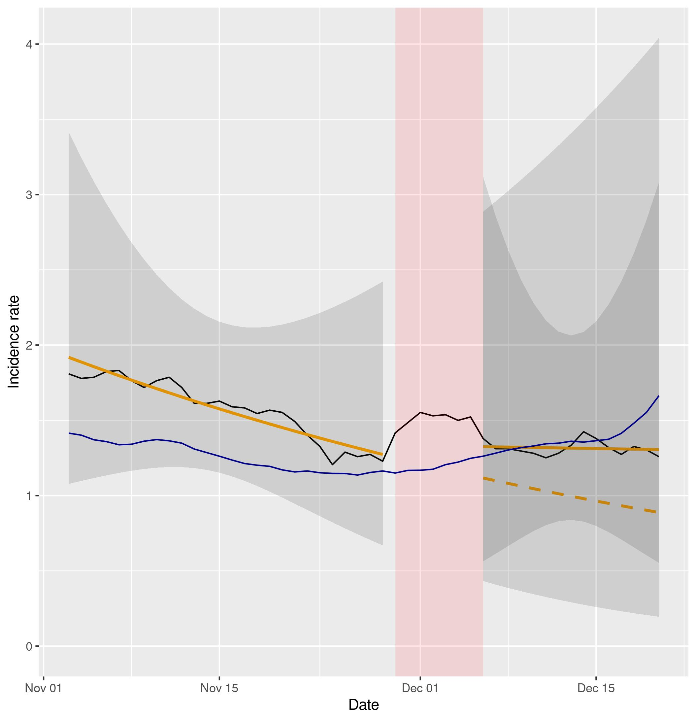
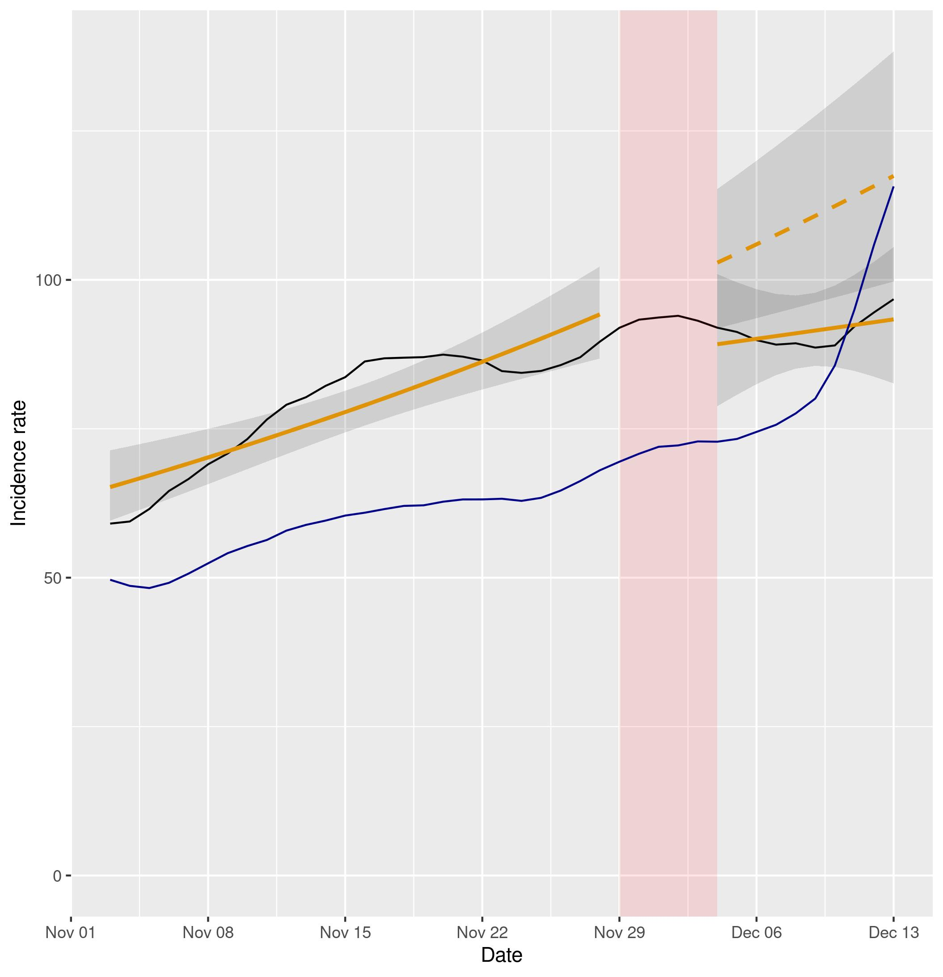

Figure 1a (left) and 1b (right). Representation of NBSR models comparing incidence rates of cases and hospital admissions in Northern Ireland (data in black, model in orange) vs England (data in blue). Dashed lines represent the expected evolution without intervention. The red shadowed area represents the neglected period post-intervention in the model due to the lag between the intervention and its effect and the grey shadowed area represents the 95% confidence intervals for the predictions.

Regarding Scotland, the incidence rate of cases presents an initial beta coefficient of 0.01 (-0.02,0.04) and a decrease in the slope of the trend of -0.01 (95% CI -0.05,0.04). Even though the impact of the intervention is deemed positive, the comparison with England fails to produce a sensible interpretation. Their trends before the intervention for cases are not sufficiently alike to be able to apply DID reasoning. As for the incidence rate of hospital admissions, the beta coefficient before the intervention is 0.01 (95% CI -0.15,0.17) and we observe a decrease in the slope of the trend after Covid Passport introduction of -0.03 (95% CI -0.25,0.20). Hence in Scotland the reduction in the outcome is evident but so it seems to be in England, where no Covid Passport measure was into effect.
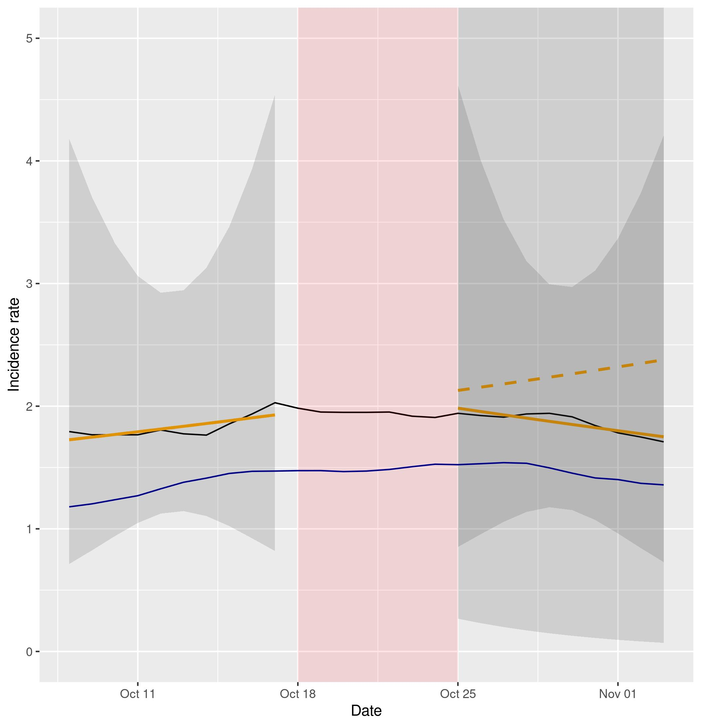
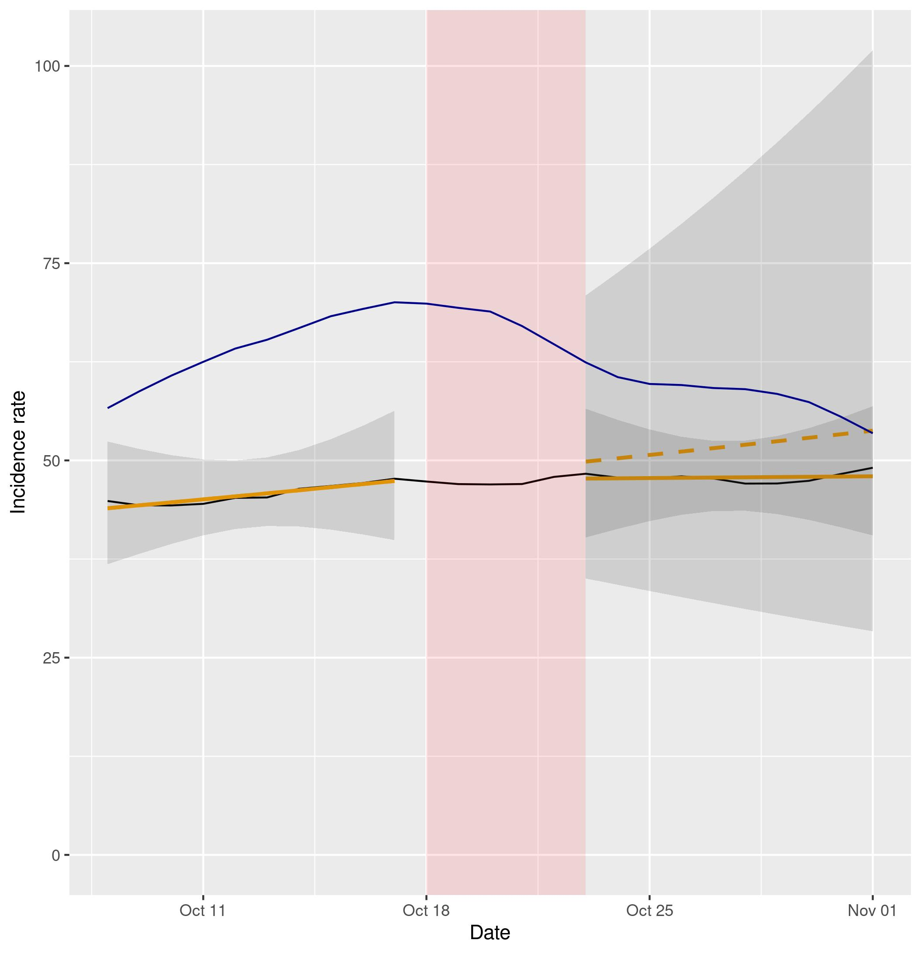

Figure 2a (left) and 2b (right). Representation of NBSR models comparing incidence rates of cases and hospital admissions in Scotland (data in black, model in orange) vs England (data in blue). Dashed lines represent the expected evolution without intervention. The red shadowed area represents the neglected period post-intervention in the model due to the lag between the intervention and its effect and the grey shadowed area represents the 95% confidence intervals for the predictions.
Note: In figure 2b the y axis has been cut to make the trends more visible, as the confidence interval for the predictions post-intervention is relatively large.

Wales plots suggest a more striking effect than in Northern Ireland, and in territories without geographic nor political barrier: while Covid Passport is associated with a slow down of cases in Wales during the second half of November, that is not seen in England (Figure 3a). The beta coefficient for Wales pre-intervention is 0.01 (95% CI -0.01,0.04) and the change in the slope of the trend is -0.01 (95% CI -0.05,0.03). Likewise, hospital admissions (Figure 3b) increased in England while decreasing in Wales in the same period.
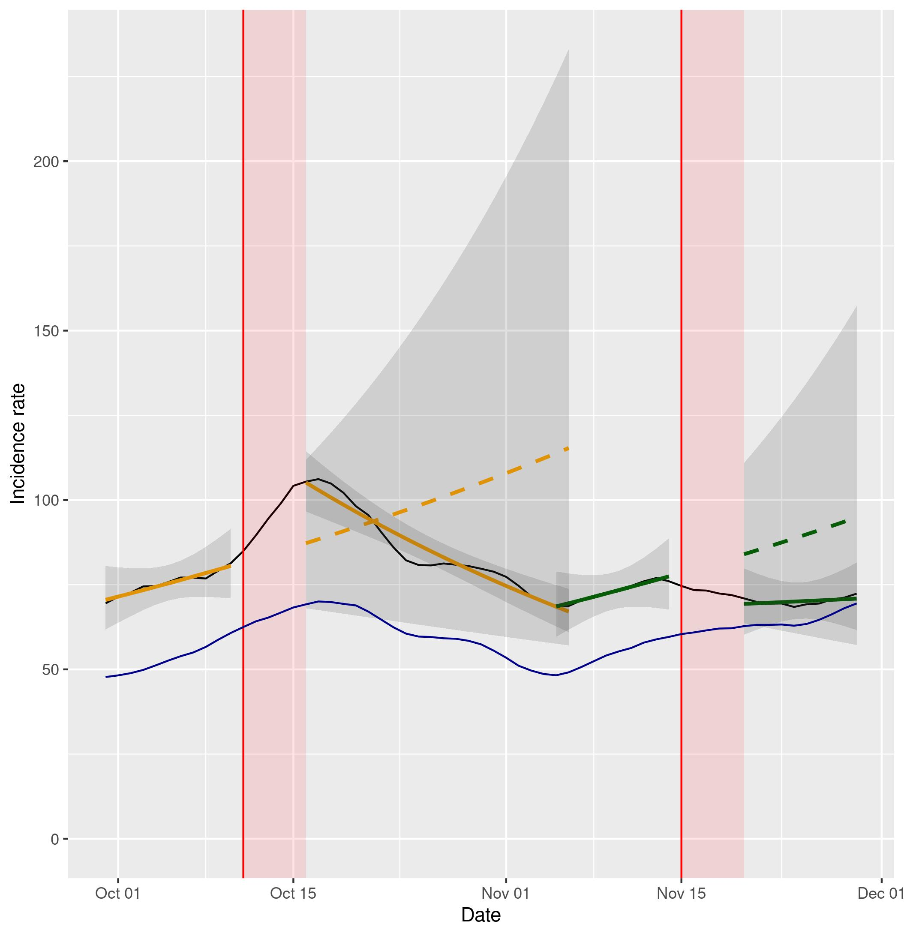
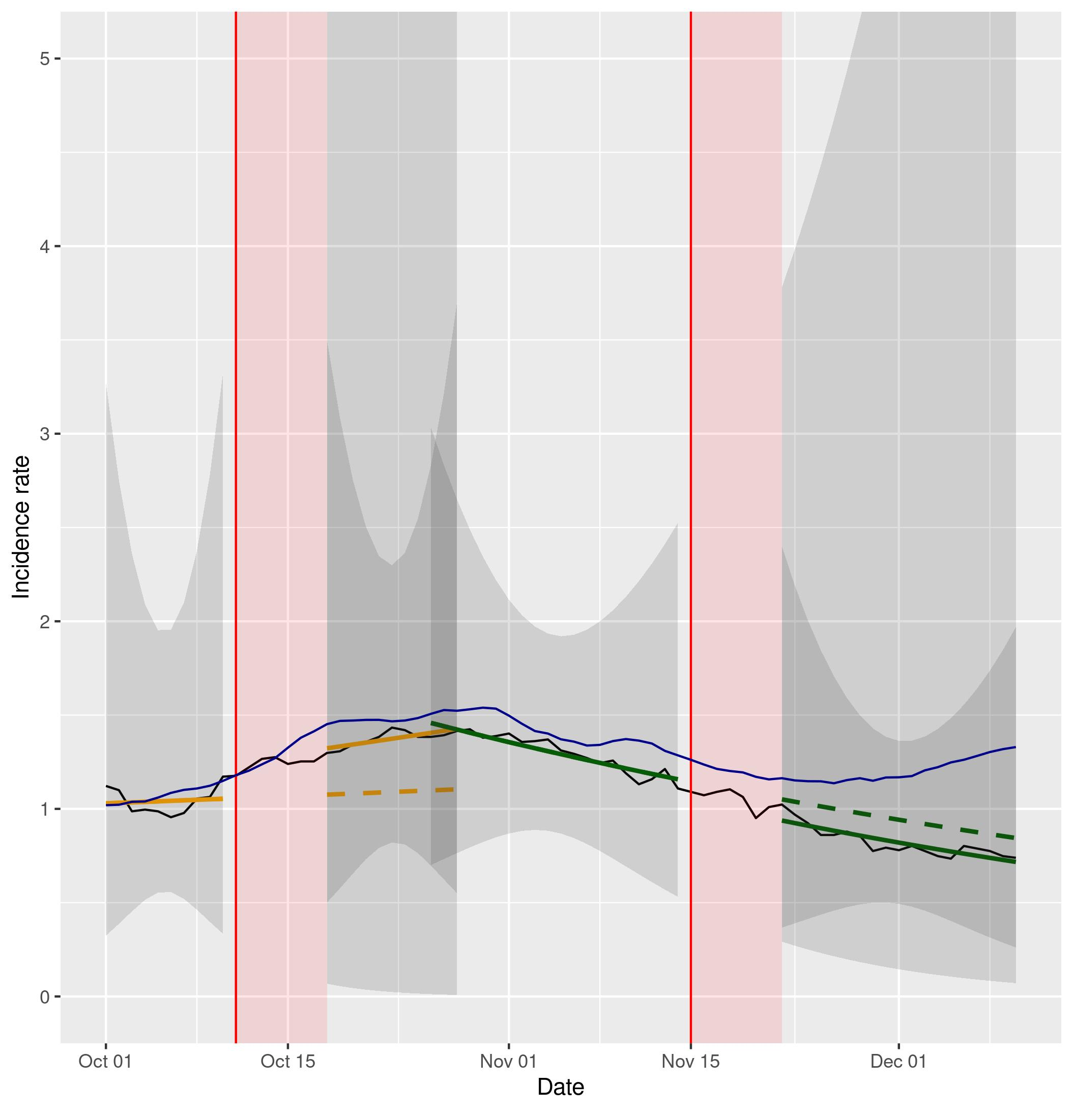

Figure 3a (left) and 3b (right). Representation of NBSR models comparing incidence rates of cases and hospital admissions in Wales (data in black, model in orange and in green) vs England (data in blue). Dashed lines represent the expected evolution without intervention. The red shadowed area represents the neglected period post-intervention in the model due to the lag between the intervention and its effect and the grey shadowed area represents the 95% confidence intervals for the predictions.
Note: In figure 3b the y axis has been cut to make the trends more visible, as the confidence interval for the predictions post-intervention is relatively large.

An assessment of England itself during its introduction of Covid Passport on the 15th December 2021 provides an estimate of the beta coefficient before the intervention of 0.02 (95% CI 0.01,0.03) and a change in the slope of the trend of 0 (95% CI -0.01,0.01) for the incidence rate of cases. As for hospital admissions, the beta coefficient before the intervention is 0 (95% CI -0.03,0.04) and the change in the slope of the trend is 0 (95% CI -0.04,0.06).
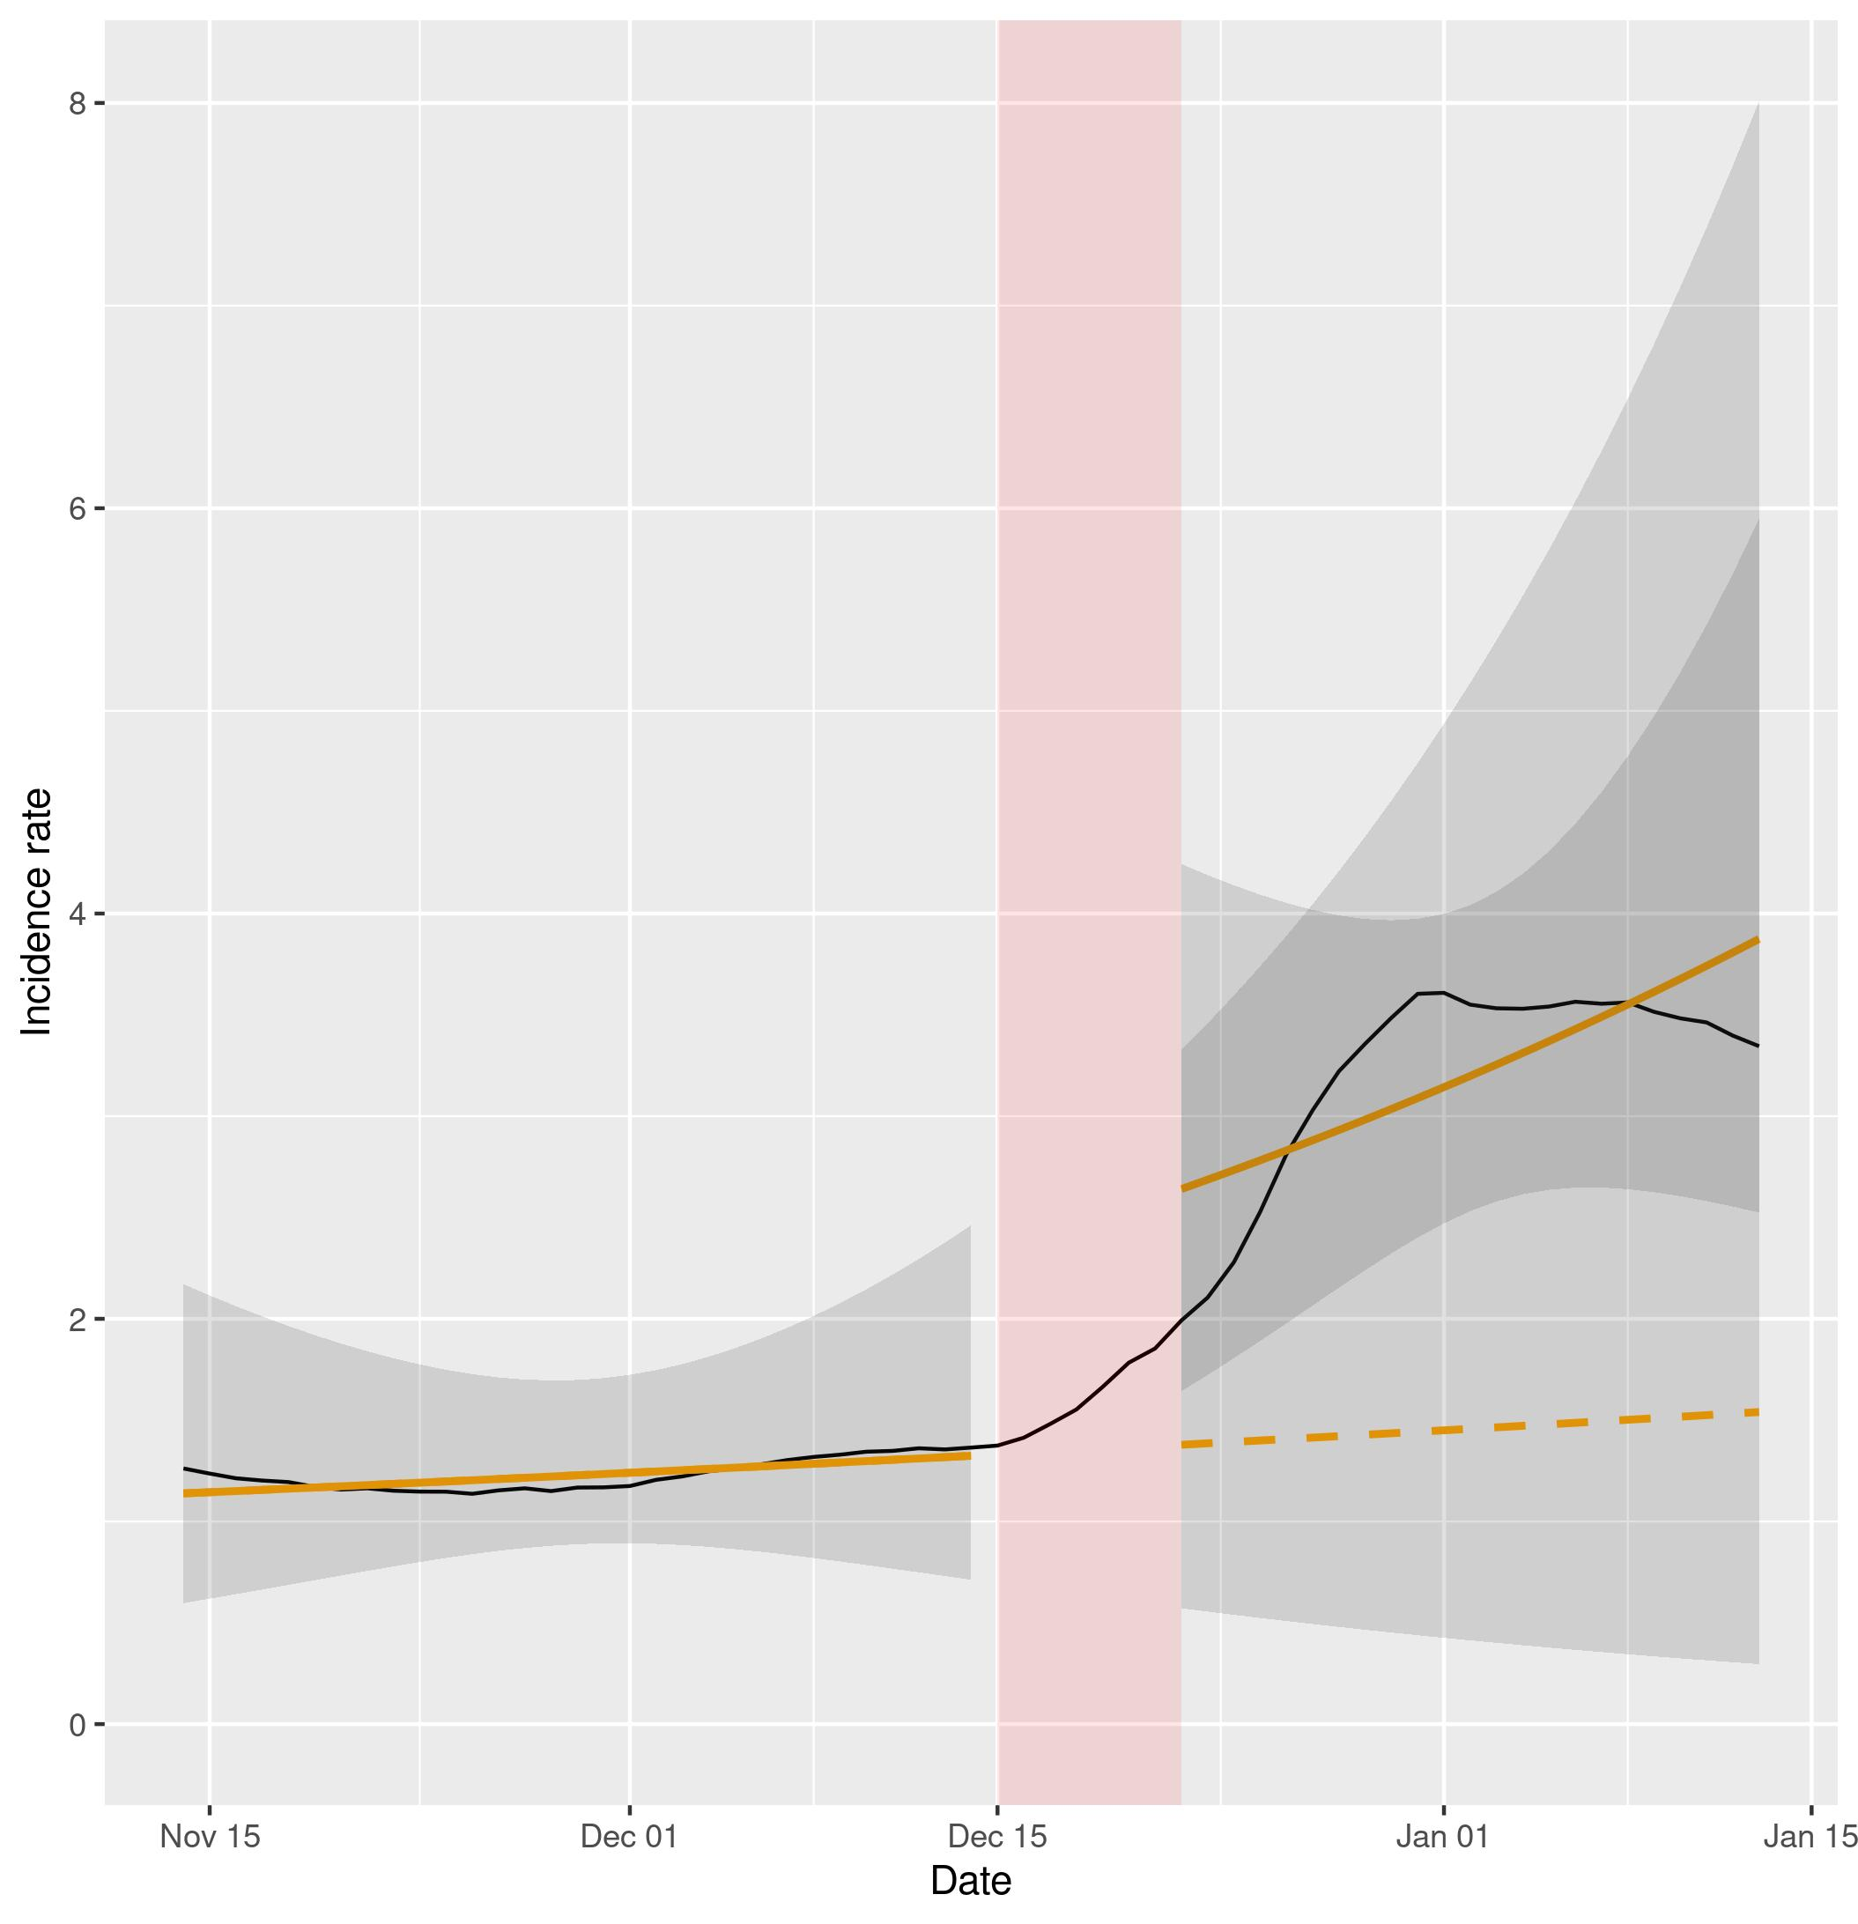
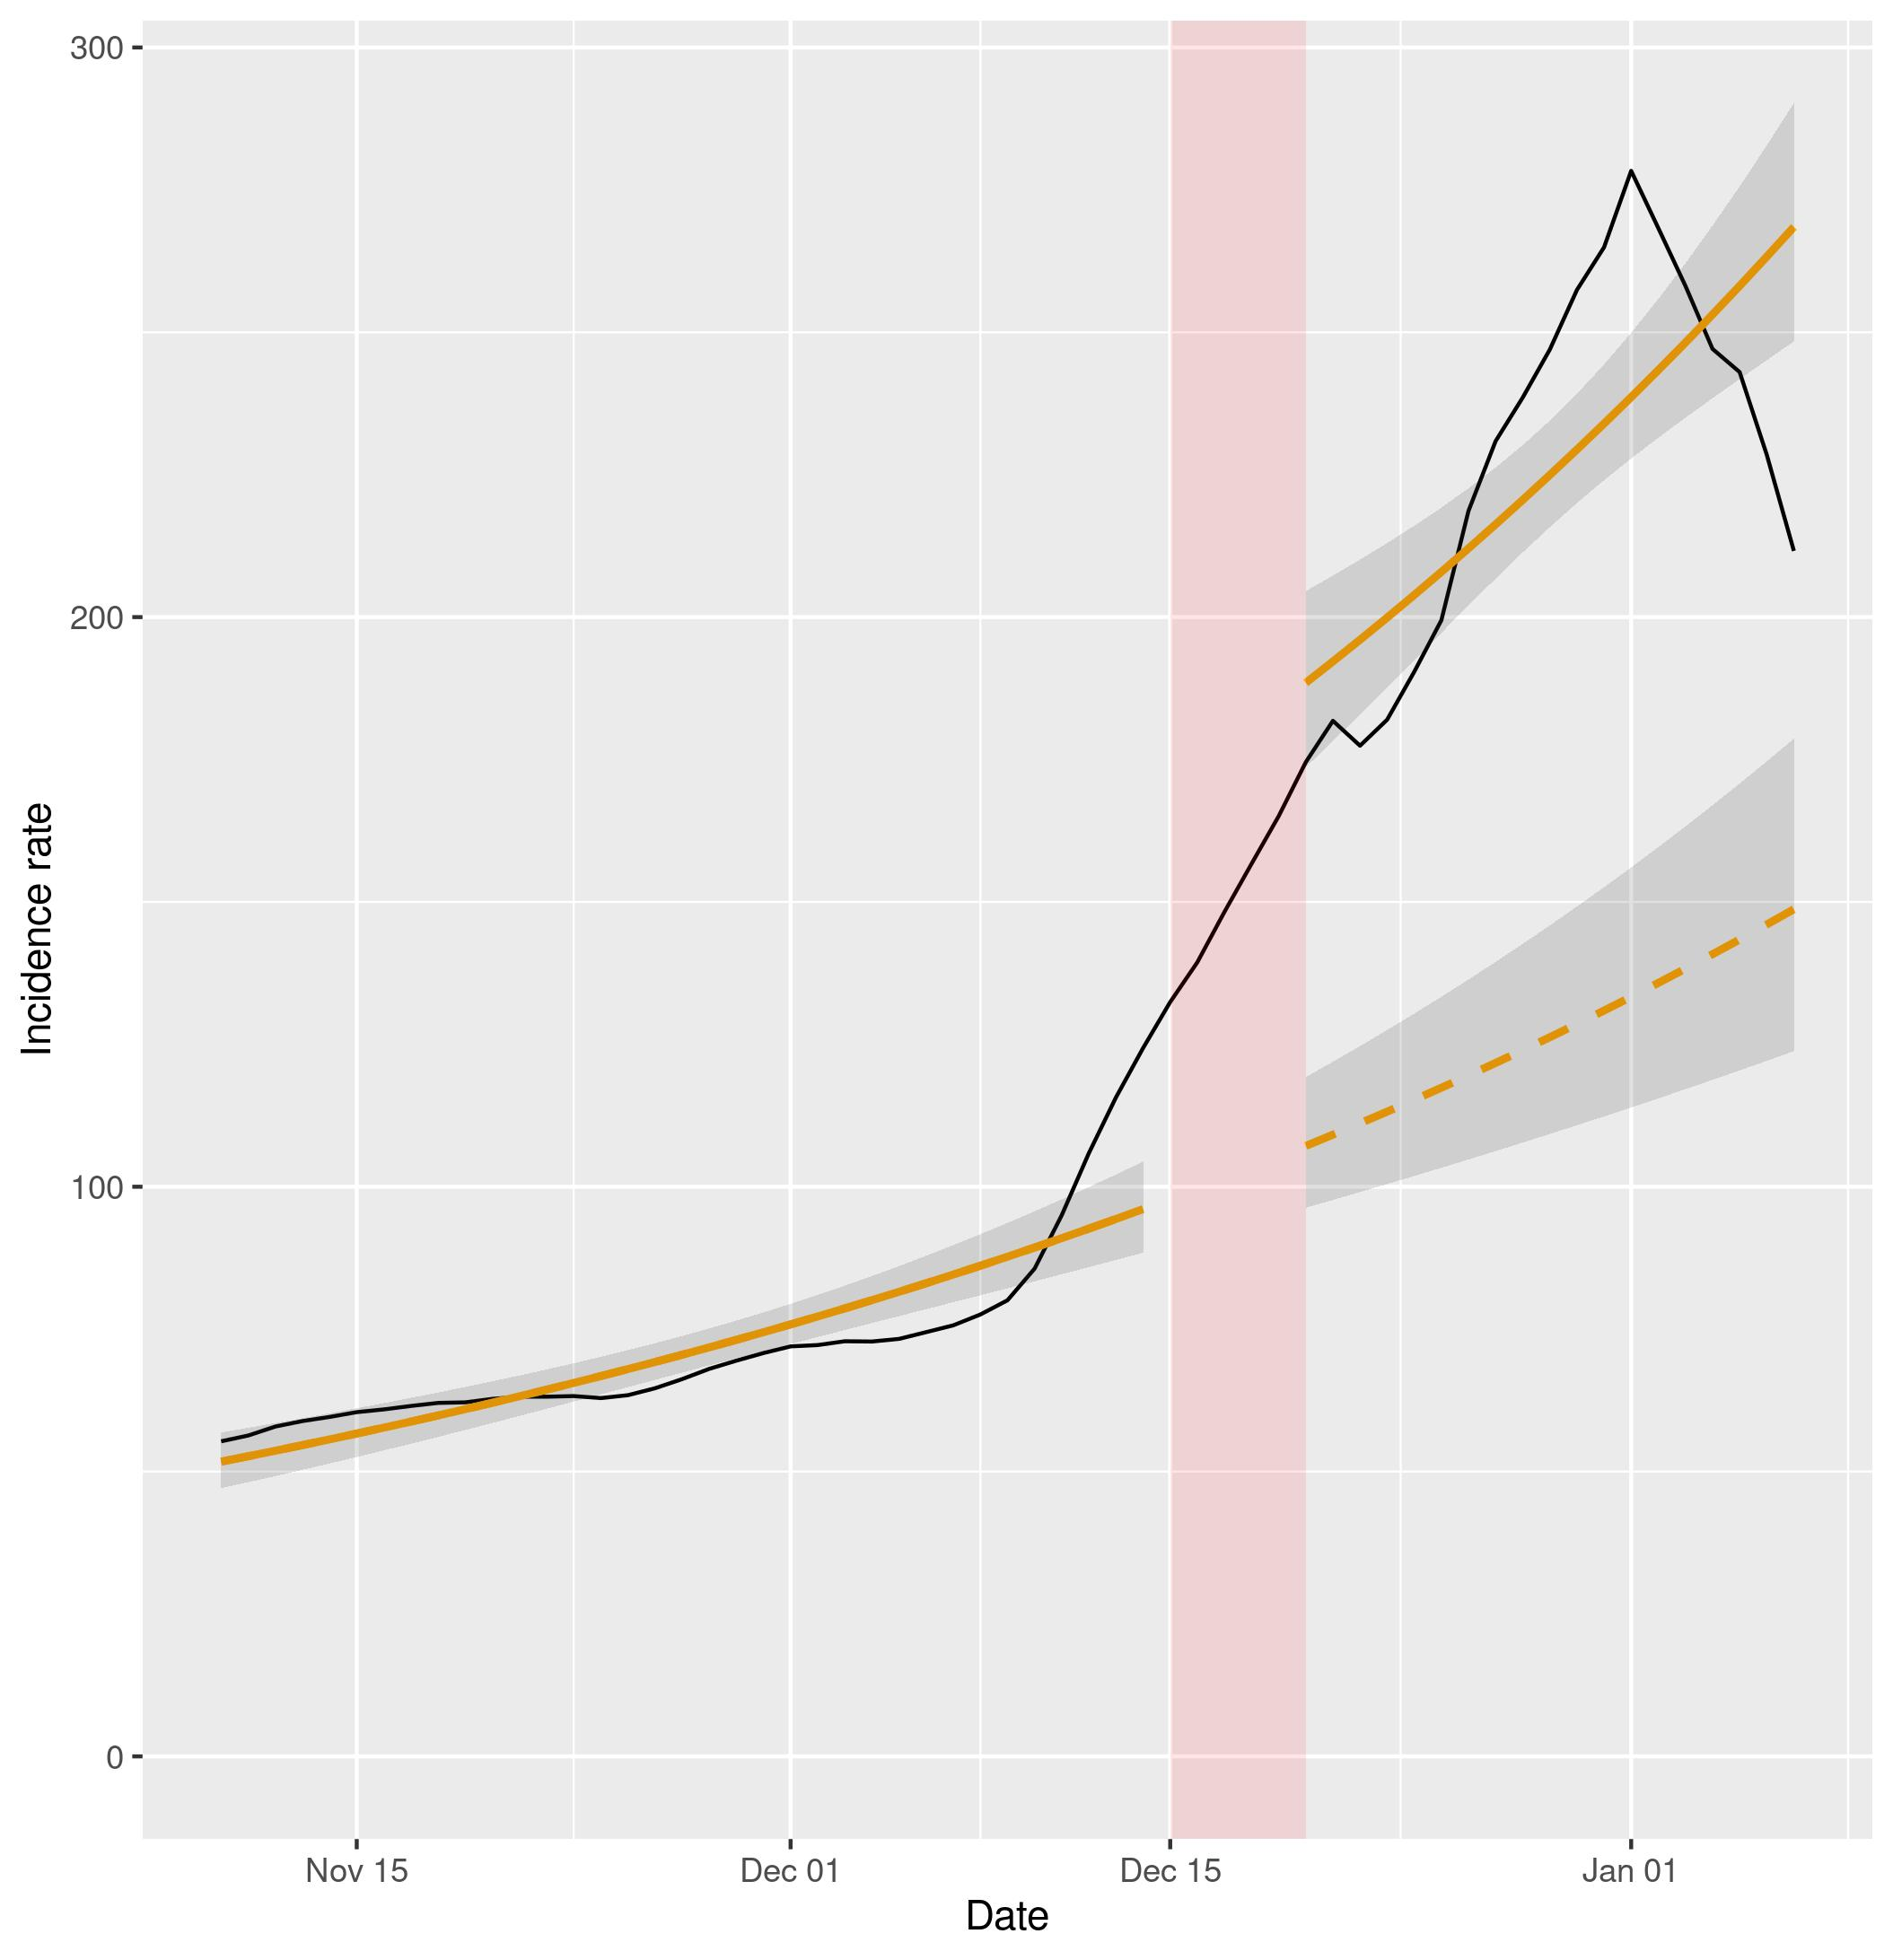

Figure 4a (left) and 4b (right). Representation of NBSR models of the incidence rates of cases and hospital admissions in England (data in black, model in orange). Dashed lines represent the expected evolution without intervention. The red shadowed area represents the neglected period post-intervention in the model due to the lag between the intervention and its effect and the grey shadowed area represents the 95% confidence intervals for the predictions.

Table 2 contains results of a DID regression for both cases and admissions incidence rates of the different UK countries (Wales, Northern Ireland, Scotland) compared to England. Except from cases in Scotland and cases in the first intervention in Wales, all the other Covid Passport introductions appear to be effective against the spreading of the virus. Note the significance of all the coefficients, in the sense that their 95% confidence interval does not include any positive sub-interval.

 | Wales CP1 | Wales CP2 | NI CP1 | Scotland CP1
Cases IR estimate | 2.22E-05 | -7.75E-05 | -1.01E-04 | 7.91E-05
95% CI cases | (-6.24E-05 , 1.07E-04) | (-1.31E-04 , -2.46E-05) | (-1.84E-04 , -1.79E-05) | (4.46E-05 , 1.14E-04)
Admissions IR estimate | -1.44E-06 | -1.69E-06 | -2.69E-06 | -9.75E-07
95% CI admissions | (-2.48E-06 , -3.93E-07) | (-3.08E-06 , -3.03E-07) | (-3.85E-06 , -1.53E-06) | (-2.19E-06 , 2.37E-07)

Table 2: Estimates and 95% confidence intervals of the effect of the Covid Passport in the DID models for the different countries and outcomes.

The first Covid Passport introduction in Wales is not seen effective in terms of reduction on the number of cases, compared to England, with an associated coefficient of 2.22E-05 (95% CI -6.24E-05,1.07E-04). As for the number of cases in Scotland, there also seems not to be any effect of the Covid Passport, with a coefficient of 7.91E-05 (95% CI 4.46E-05,1.14E-04).

However, both countries show significant effects on the incidence rate of hospital admissions, with DID coefficients of -1.44E-06 (95%CI -2.48E-06,-3.93E-07) and -9.75E-07 (95% CI-2.19E-06,2.37E-07) respectively. The second Covid Passport intervention in Wales is deemed effective for both outcomes, with a coefficient of -7.75E-05 (95% CI -1.31E-04,-2.46E-05) for incidence rate of cases and -1.69E-06 (95% CI -3.08E-06,-3.03E-07) for incidence rate of admissions. Northern Ireland shows a similar result, with coefficients -1.01E-04 (95% CI -1.84E-04,-1.79E-05) and -2.69E-06 (95% CI -3.85E-06,-1.53E-06) for incidence rates of cases and hospital admissions respectively.
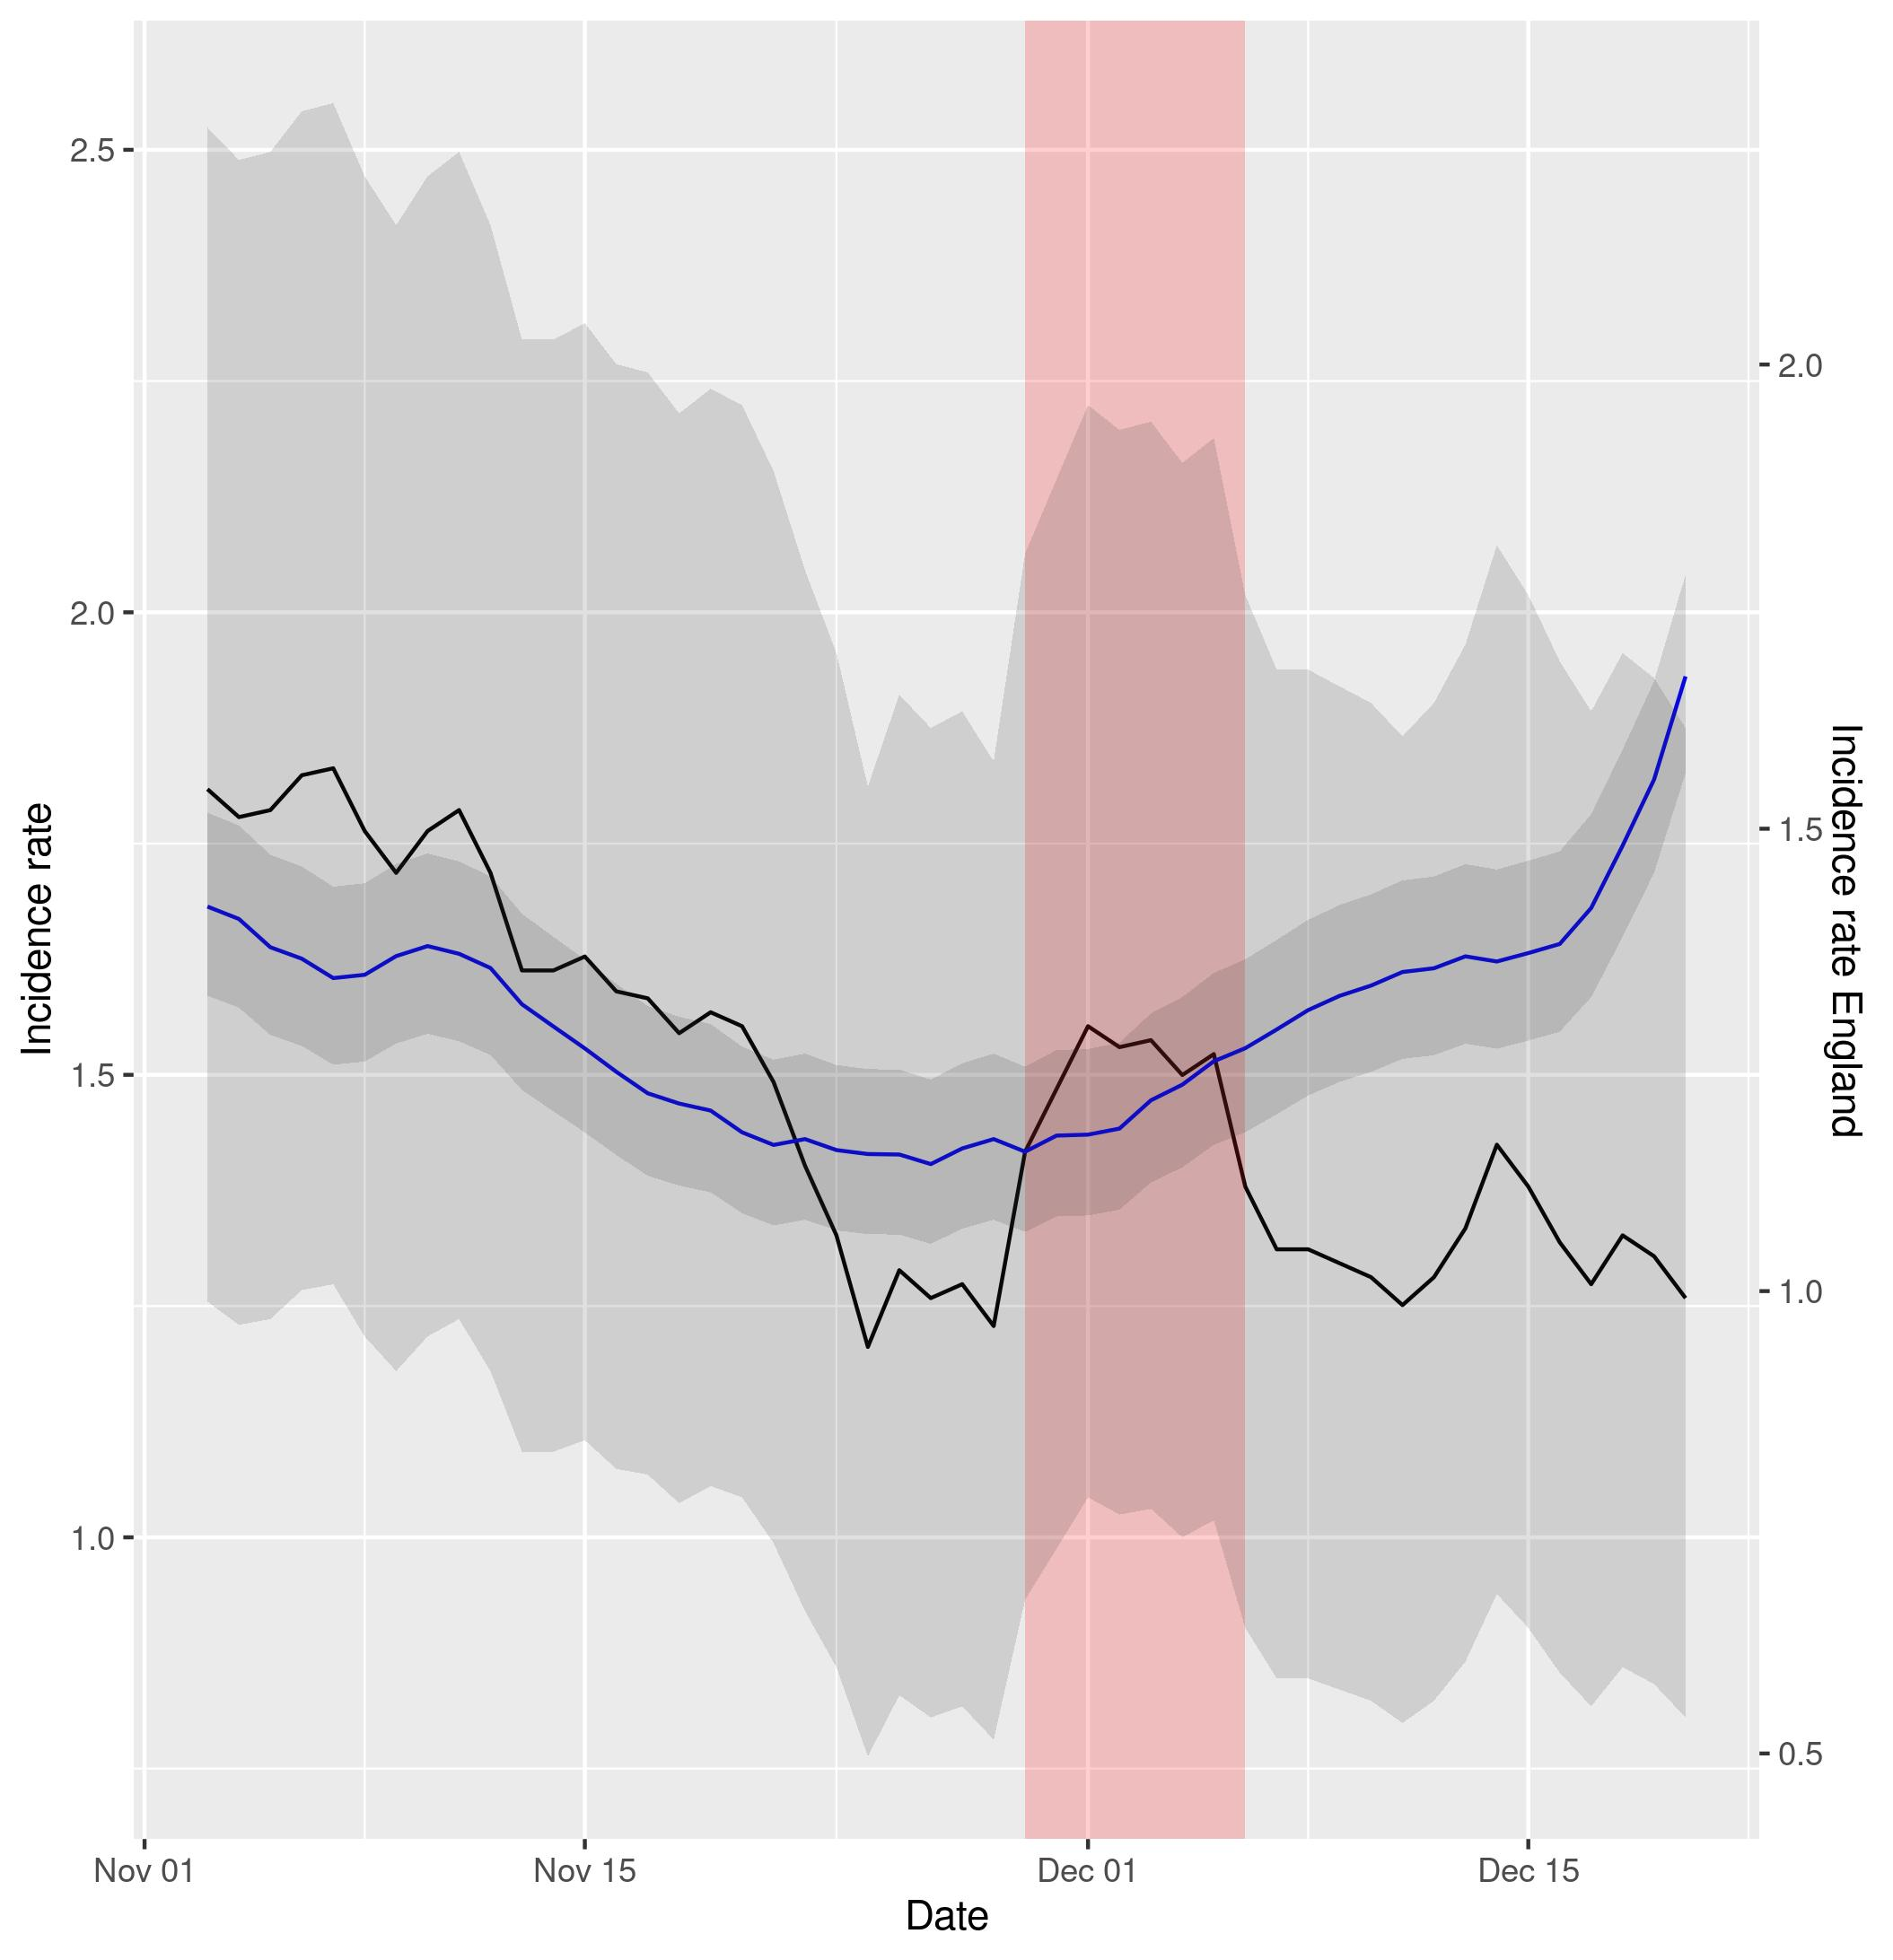
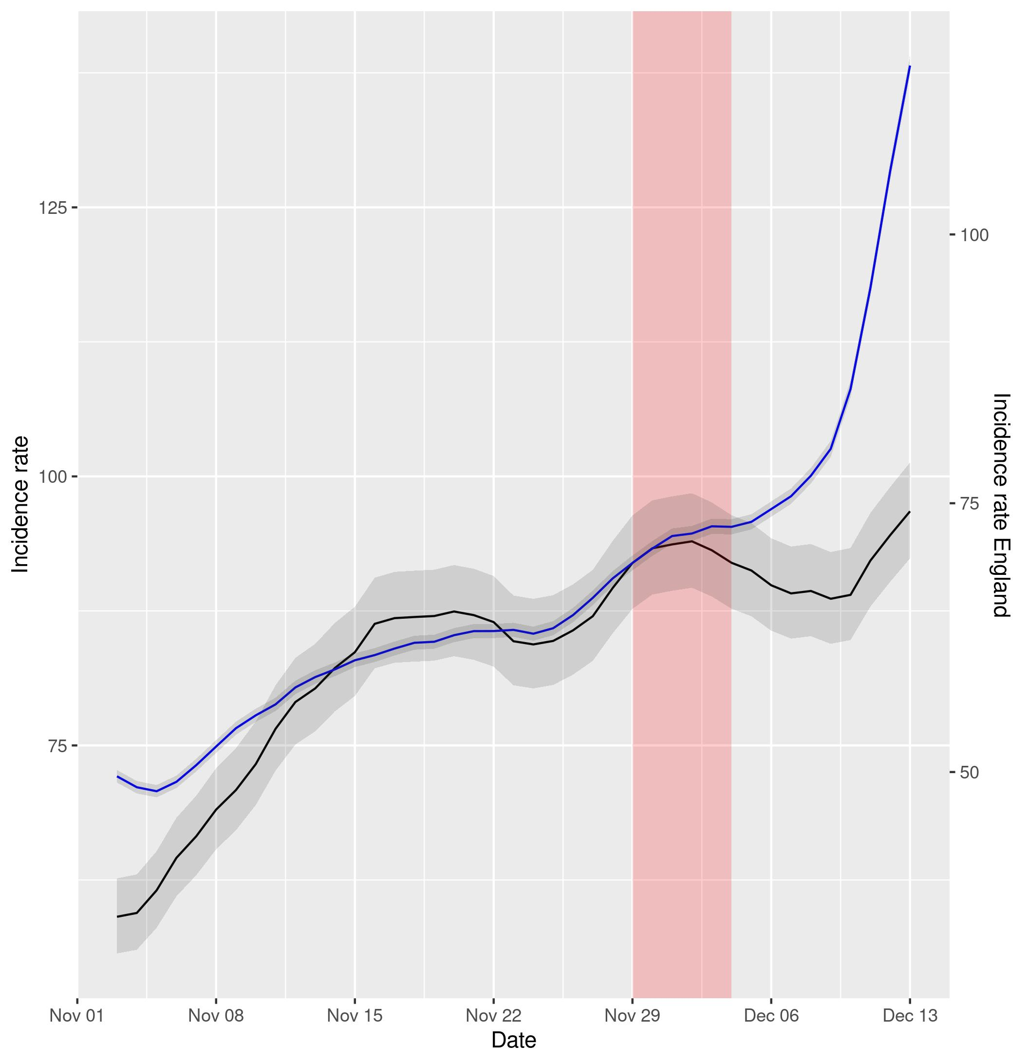

Figure 5a (left) and 5b (right). Representation of incidence rates of cases and hospital admissions in Northern Ireland (data in black) vs England (data in blue). Data has been displaced so that both curves intersect right at the intervention time point. The red shadowed area represents the neglected period post-intervention in the model due to the lag between the intervention and its effect and the grey shadowed area represents the 95% confidence intervals of the calculation of incidence rates.

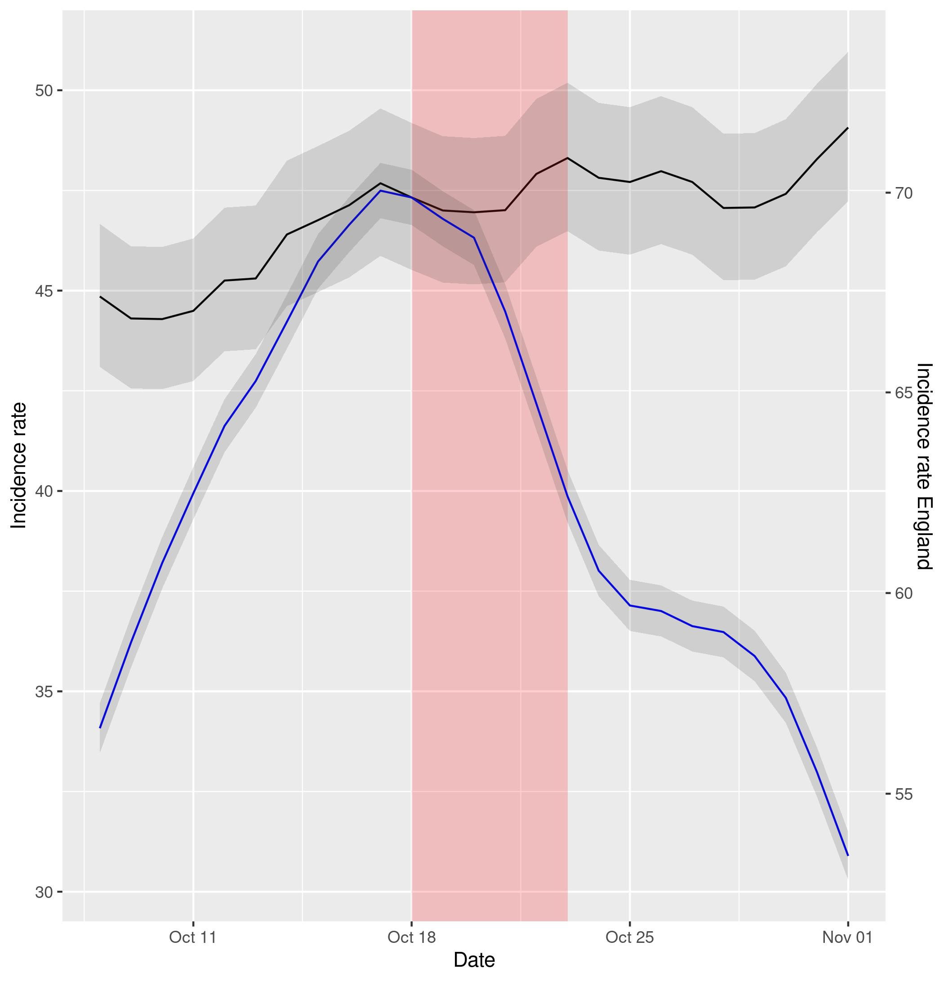
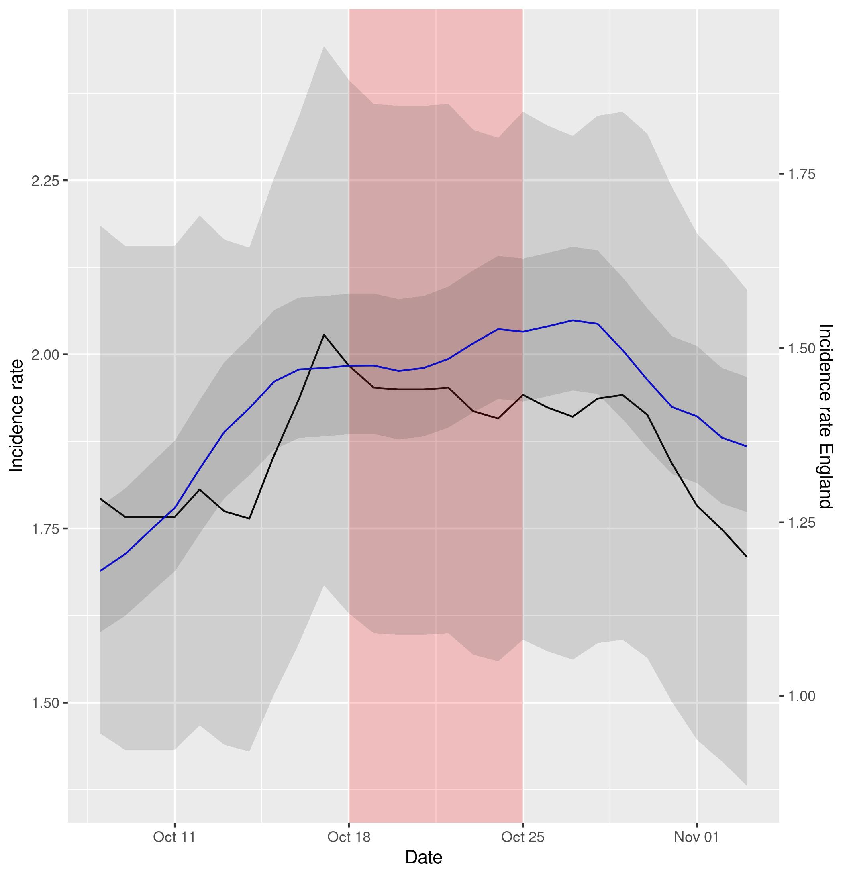

Figure 6a (left) and 6b (right). Representation of incidence rates of cases and hospital admissions in Scotland (data in black) vs England (data in blue). Data has been displaced so that both curves intersect right at the intervention time point. The red shadowed area represents the neglected period post-intervention in the model due to the lag between the intervention and its effect and the grey shadowed area represents the 95% confidence intervals of the calculation of incidence rates.

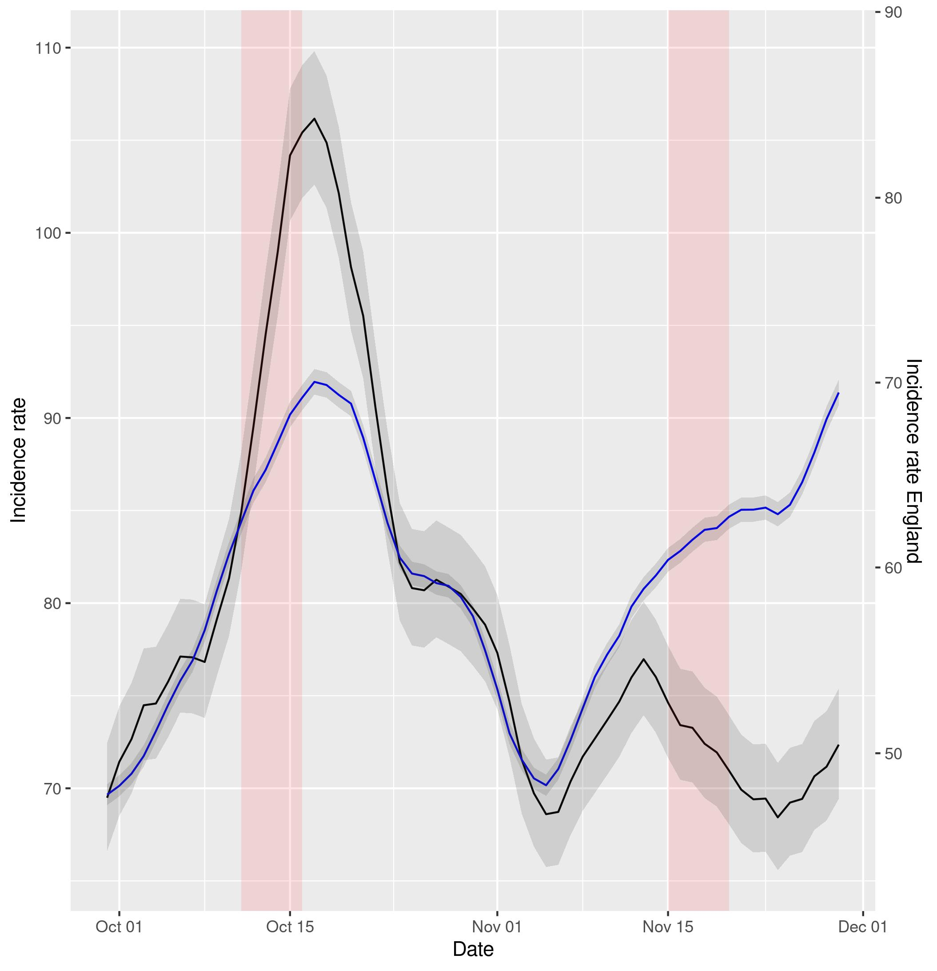
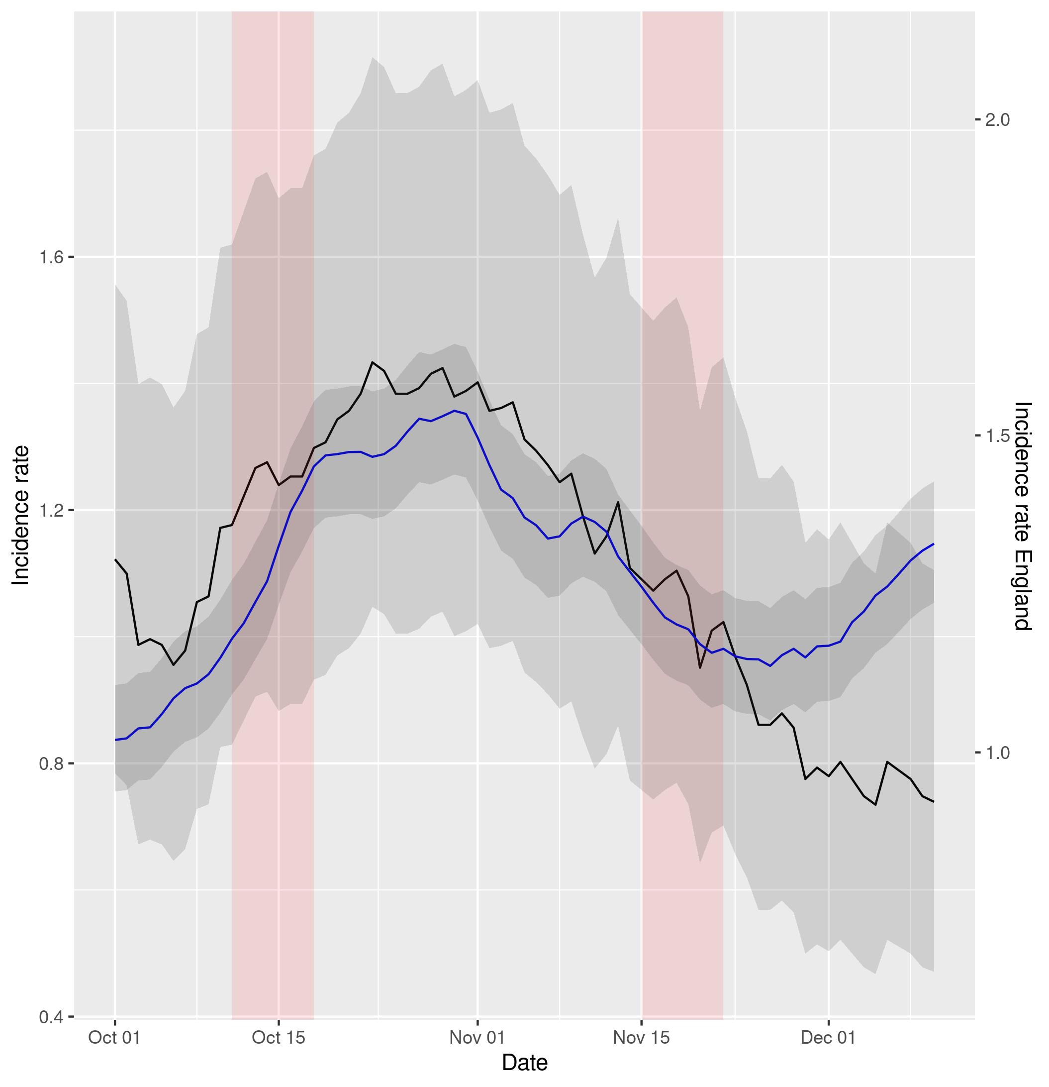
Figure 7a (left) and 7b (right). Representation of incidence rates of cases and hospital admissions in Wales (data in black) vs England (data in blue). Data has been displaced so that both curves intersect right at the intervention time point. The red shadowed area represents the neglected period post-intervention in the model due to the lag between the intervention and its effect and the grey shadowed area represents the 95% confidence intervals of the calculation of incidence rates.

I am not sure if we should include sensitivity analyses, as I tentatively wrote in the Research Proposal.

